Glen Alice Gossip
Term 1, Week 10

Term 1 has flown by and I can’t believe we are almost on holidays again. I apologize for not doing a newsletter earlier in the term however, it seems that my office days have been even more busy than usual.

Welcome
This term we would like to welcome four new children and their families. We hope you have an enjoyable association with our school.

Swimming Carnival
The school year started with Mudgee Small Schools Swimming Carnival. For some students it was their first time in the big pool. Our Glen Alice students swam well and many ribbons were won. A great day was had by all.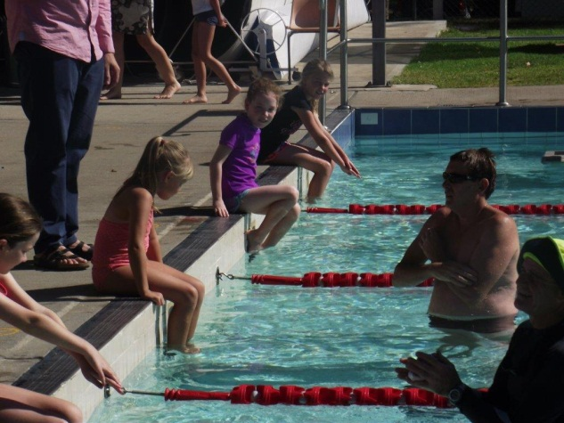
Shauna nervously awaits the start of her first big pool race.

Science Day at Ilford PS
On 4th March we went to Ilford for a Science Day. Stage groups rotated through four different activities which focused on plant growth, the senses, air pressure and geology.

Sydney Royal Easter Show
Glen Alice students will enter the Steggles Meat Bird Pairs School competition at the Sydney Royal this year. We received our day old chickens by courier on 26th February and have been caring for them since then. The students are finding that there is a lot involved in raising meat chickens. The food and the chickens are weighed regularly in order to work out the feed conversion. At last weigh in our chickens averaged 1.3kg. Next Monday the best pair of males and the best pair of females will be bathed and blow dried for the show on Tuesday. The remaining chickens will be for sale at $10.00 each.

Tashi
On 18th of March we all piled into the bus and travelled to Bathurst to see a wonderful play about Tashi. The children very much enjoyed the fabulous acting and props. They also had a lovely play at the Dinosaur Park and a delicious ice-cream at McDonalds.

Public Speaking
Our Mudgee Small Schools Public Speaking Competition will be held this year at the Mudgee Town Hall Theatre on Friday, 4th of April. Students need to be at the hall by 9:15am for a 9:30am start. The transport to this event is by parent arrangement.

P&C Bulb fundraiser
I hope by now you have all received a bulb catalogue and are busy thinking Spring gardening thoughts. If anyone knows of someone who would like a catalogue and hasn’t got one, please see our new P&C President Kathy Grimshaw.

Dates for the Diary
1/4 Police visit
4/4 Public Speaking
8/4 Life Ed Van at Cullen Bullen PS
11/4 Primary students excursion to Sydney Royal
11/4 last day of term 1
29/4 first day term 2
13/4, 14/4, 15/4 Naplan
29/4 Space Day at Hill End
As always, if you have any queries about what is happening in our school please feel free to pop in.
Kind Regards,
Natalie

